**How do School Bond assessments fit into the picture?**

Piedmont school bond assessments will grow until 2018 - to a maximum of $1,465 on a home with an assessed value of $1 million. This amount is in addition to $2,000 to $3,400 in annual parcel taxes.

While a limited cost of $60 per $100,000 of assessed value was guaranteed for Measure E school bonds, the $60 limit did not include older existing bonds assessments. Combined old and new assessments were restricted to **$146.50 per $100,000 of assessed value.**

Measure E bonds (unrelated to the emergency Measure E parcel tax) were approved by voters to build the new Havens Elementary School and complete various seismic and ADA projects at other school sites.

Neither bond funds nor bond assessments can be used for normal school operating expenses. School bond assessments are used exclusively to repay bonds issued by the Piedmont Unified School District for school construction projects. Funds raised by issuing construction bonds are kept in a separate Bond Fund and are not part of the PUSD operating budget.

The chart below shows that older existing bonds for pre-2006 construction created assessments of $80 per $100,000 per parcel until 2018. Initial Measure E bonds were structured to add $20 through 2020, and then increase to $60; subsequent Measure E bonds added an additional unspecified assessment. The financial structure limited **total combined bond assessments to $146.50**, but increased total interest costs by shifting repayment to later years.

Originally, the total cost of Havens and other seismic/ADA work was projected at $69 million, with the difference between Measure E bonds ($56 million) and the total cost of construction work coming from a state program. When this extra state funding was threatened, the PUSD successfully applied for a variety of school bond programs, some of which are not limited to seismic retrofitting.

The PUSD now anticipates receiving a total of $74 million. Extra funds are first being used to repair or replace roofs (Beach, Wildwood, Piedmont Middle School, and the Harvey Theatre), replace some HVAC systems (Wildwood, Piedmont Middle School) and develop schematic plans to remodel and expand the Harvey Alan Theatre based on a design concept prepared by Mark Becker. Becker’s design concept expands the Theatre building by 3,200 square feet and moves the entrance to the front of the High School (facing Magnolia Avenue).

In the future, a decision will be made: whether to forge ahead with the Theatre and/or other projects, or to avoid increasing bond payments on taxpayers.

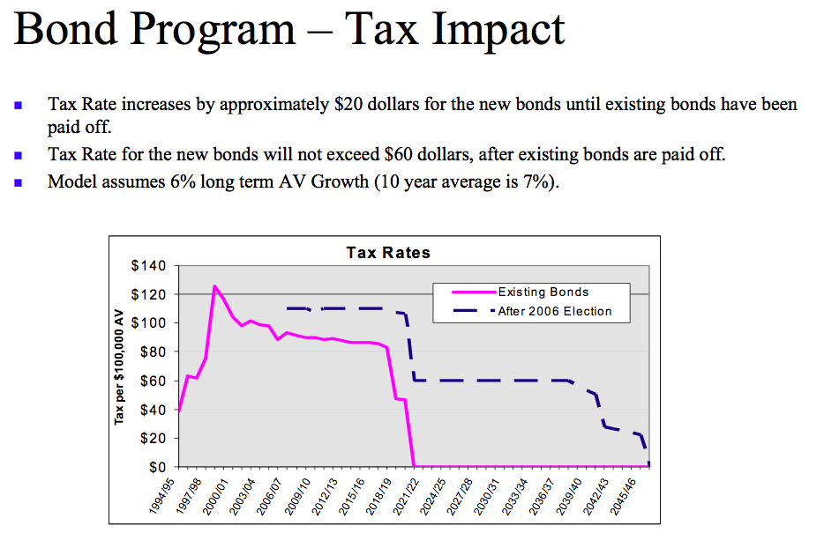

**Bond assessments as of 2006 (includes initial bonds issued under Bond Measure E);**

***Source:*** [***2006 PUSD Rating Presentation***](http://www.piedmont.k12.ca.us/aboutpusd/agenda.minutes/PiedmontUSD_Rating.pdf)

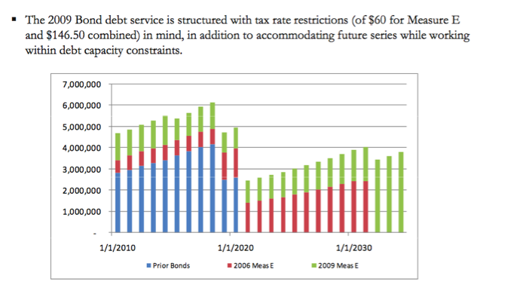

**Bond assessments as of 2009 (includes later bonds issued under Bond Measure E);**

***Source:*** [***2009 PUSD Rating Presentation***](http://www.piedmont.k12.ca.us/aboutpusd/agenda.minutes/PiedmontUSD_Rating.pdf)