**How do School Bond assessments fit into the picture?**

Piedmont school bond assessments will grow until 2018 - to a maximum of $1,465 on a home with an assessed value of $1 million. This bond assessment is in addition to $2,000 to $3,600 in annual parcel taxes. Decisions will also be made in the near future on whether to levy further bond assessments to build a new High School theatre and complete other projects beyond $69 million in school seismic work - - or forego increasing bond payments on taxpayers above $146.50 per $100,000 per home.

While a limit of $60 per $100,000 of assessed value was guaranteed for Measure E school bonds, that limit did not include older existing bonds assessments. Combined old and new assessments are restricted to about **$146.50 per $100,000 of assessed value.**

New Measure E bonds (completely unrelated to the Measure E emergency parcel tax) were approved by voters to build the new Havens Elementary School and complete various seismic and ADA projects at other school sites.

Bond funds cannot be used for normal school operating expenses. Funds raised by issuing school construction bonds are kept in a separate Bond Fund and are not part of the PUSD operating budget. School bond assessments levied on property are used exclusively to repay the bonds.

The chart below shows that older existing bonds for pre-2006 construction created assessments of $80 per $100,000 per parcel until 2018. Initial Measure E bonds were structured to initially add only $20 (through 2020) and then increase to $60 when the older bonds expired. Subsequent Measure E bonds added an additional unspecified assessment, but **total combined bond assessments will be limited to about $146.50**. Total interest costs are increased by shifting early repayments to later years.

Originally, the total cost of Havens and other seismic/ADA work was projected at $69 million, with the difference between Measure E bonds ($56 million) and the total cost of construction work ($69 million) coming from the state. When the extra state funding was threatened, the PUSD successfully applied for a variety of school bond programs. Some are not limited to seismic retrofitting.

The PUSD is now eligible to receive a total of $74 million. The new additional funding is first being used to repair or replace roofs (Beach, Wildwood, Piedmont Middle School, and the Harvey Theatre), replace some HVAC systems (Wildwood, Piedmont Middle School) and develop schematic plans to remodel and expand the Harvey Alan Theatre based on a design concept prepared by Mark Becker. Becker’s design concept expands the Theatre building by 3,200 square feet and moves the theatre entrance to the front of the High School (Magnolia Avenue).

In the future, decisions will be made on whether to forge ahead with the Theatre and/or other projects or forego increasing bond payments on taxpayers.

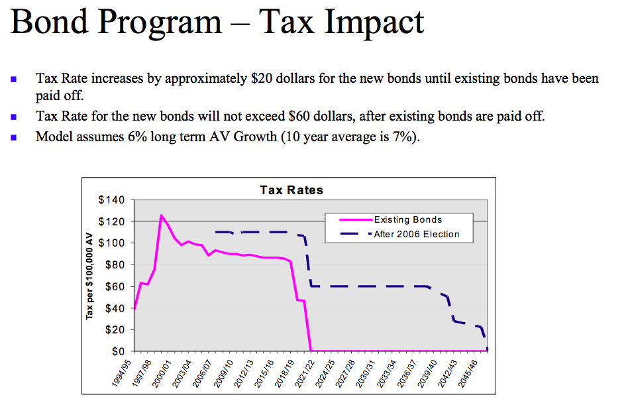

**Bond assessments as of 2006 (includes initial bonds issued under Bond Measure E);**

***Source:*** [***2006 PUSD Rating Presentation***](http://www.piedmont.k12.ca.us/aboutpusd/agenda.minutes/PiedmontUSD_Rating.pdf)

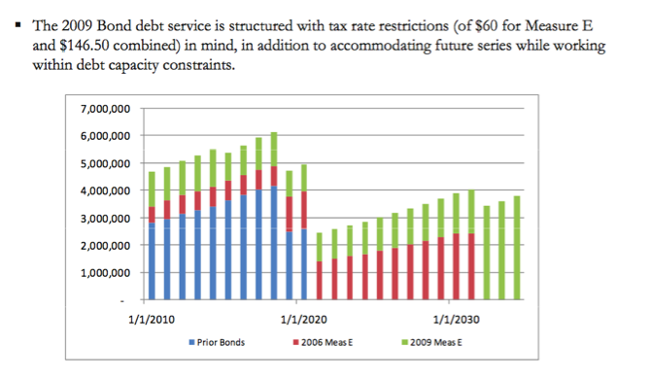

**Bond assessments as of 2009 (includes later bonds issued under Bond Measure E);**

***Source:*** [***2009 PUSD Rating Presentation***](http://www.piedmont.k12.ca.us/aboutpusd/agenda.minutes/PiedmontUSD_Rating.pdf)